**Q: 15**

**Title:**

L2 - Building a Responsive Image Gallery

**Problem Statement:**

Refer this Layout and create a responsive Image gallery : 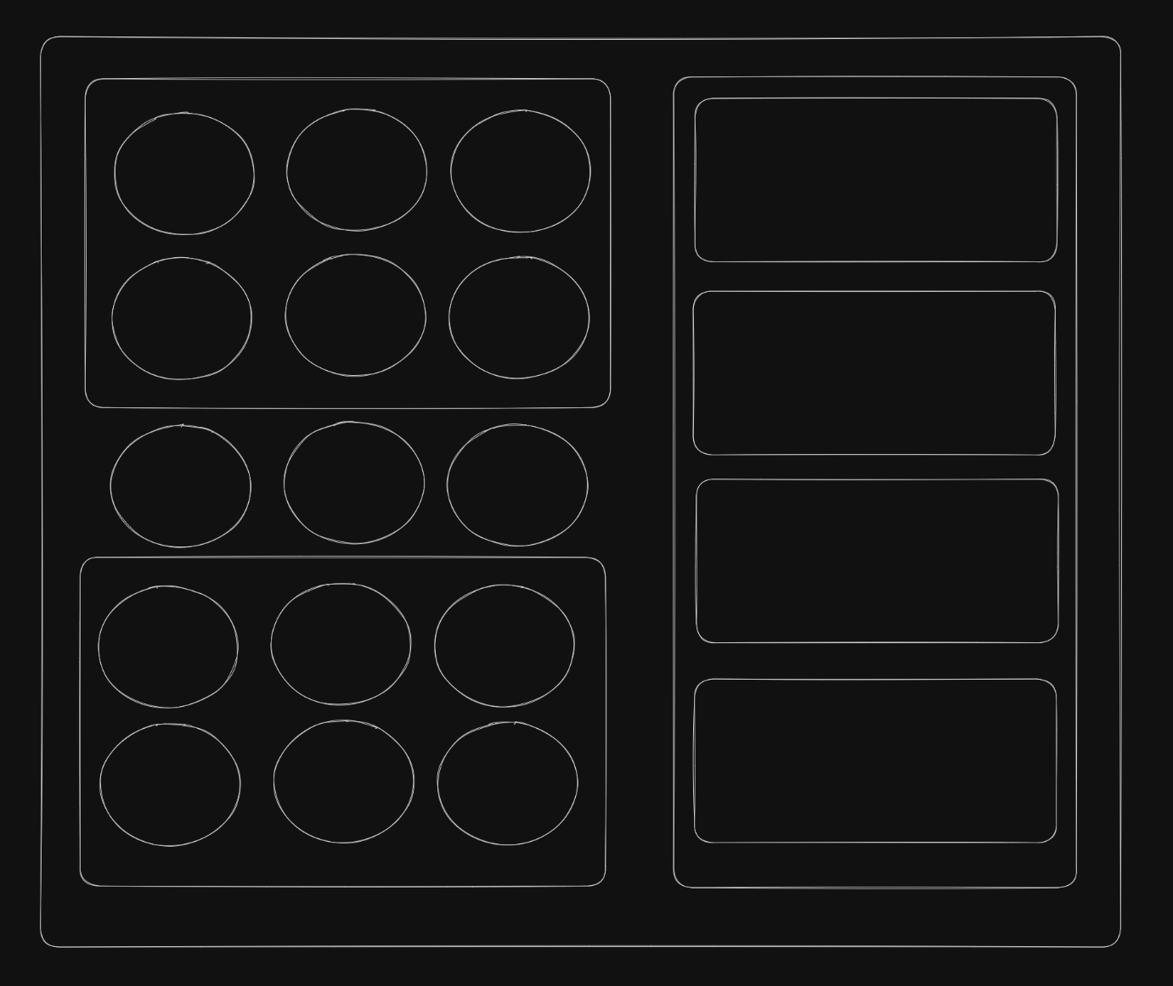

**Note :** the defining feature here will be applying responsiveness , now you're free to display the layout in whichever way you like but whenever the screen size is changed it should dynamically update the layout .

You are free to use placeholder images (e.g., from [Lorem Picsum](https://picsum.photos/)).

**Submission Guidelines:**

* Submit the link to your Masai Git repository containing the HTML and CSS files.